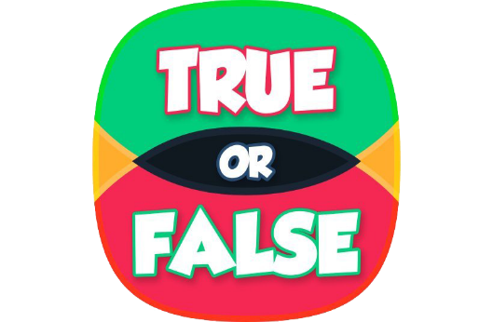

True or False Statements – Circle the answer you believe to be True or False.

- A fundamental point of a strengths-based approach is that it is an ‘approach’, not an outcome or a process. It is less about ‘what the end result is’, or ‘what we do’, and more about ‘how we do things’
TRUE or FALSE

- Supporting the person's strengths can help address needs (whether or not they are eligible) for support in a way that allows the person to lead, and be in control of, an ordinary and independent day-to-day life as much as possible. ​
TRUE or FALSE

- ‘Care and Support’ is a service delivered to an individual to help them.
TRUE or FALSE

- An Assessment should focus only a persons needs.
TRUE or FALSE

- A principle of Community Led Support ‘People are treated as Equals, their strengths and gifts built on’ ​
TRUE or FALSE

- It is not important for the practitioner to have an objective understanding of the individual's views and ensure that strengths, needs and outcomes have not been over- or underestimated. ​
TRUE or FALSE

- Practitioners assessing a person should involve an advocate (a family member, friend or independent advocate) to help the individual through the process if they have substantial difficulty understanding, retaining and using the relevant information. ​
TRUE or FALSE

- Working from a strengths-based position, is about 'giving people less support and services’. ​
TRUE or FALSE

- Another Principle of Community Led Support is: ‘There is a focus on communities and each will be different’. ​
TRUE or FALSE

- Most of the support should be provided by the person’s family. ​
TRUE or FALSE

